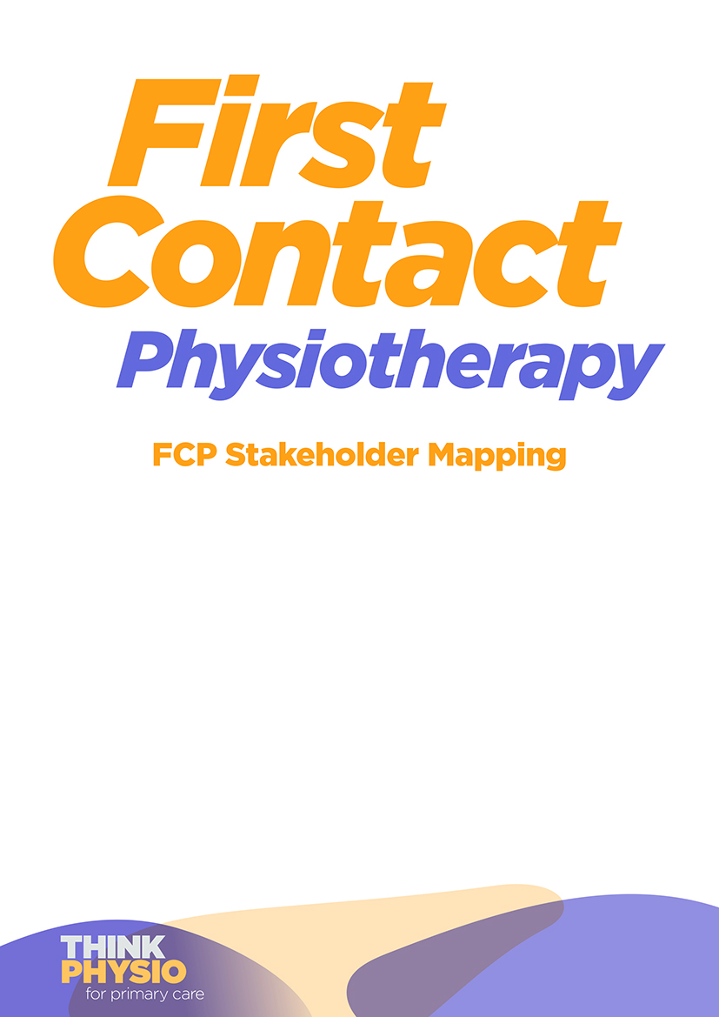

Mapping Stakeholders for Successful FCP Implementation
This resource provides an outline of a method to support stakeholder mapping. Comprehensive mapping of key stakeholders will ensure that the introduction of First Contact Practitioner roles into the Primary Care Network has engagement from key individuals and organisations. Stakeholder engagement from project initiation and throughout implementation will ensure elements critical to the FCP role are considered to ensure successful implementation and service sustainability.
A new service will require a business case together with a project plan in line with project management methodology. At the outset a project sponsor at senior management or executive level is needed to advise and ensure engagement from senior executives throughout the duration of the project. The project sponsor will provide oversight to the process and should inform the stakeholder mapping process. Accountable to the project sponsor is the project manager to run and manage the project according to the plan and to report to the sponsor.

Stakeholder mapping
Stage 1 Identify the proposed patient pathway for the FCP service. Use the patient journey beginning when the patient has a need to seek guidance, to entering the service through until discharge. For the patient and others involved with care navigation, the stage before the patient actually enters the service should be included. Essential to this is awareness of the scope and purpose of the service which will affect engagement with the pathway.
Stage 2 Identify the stakeholders along the pathway. Identify all individuals and services involved with directly delivering the service and those who will influence its delivery or be influenced by FCP implementation.
Stage 3 Consider requirements from the service both internally and externally and lines of accountability. Consider the legal, regulatory, professional, organisational and individual responsibilities and requirements. This should include national and local requirements from organisations such as NHSE/I through to local governance arrangements. Consider what representation is needed from organisations to ensure the FCP role can be safely delivered and meet the needs of the local health economy and individuals within the organisation who can ensure requirements can be met.
Stage 4 Identify the roles stakeholders will be drawn from. Once the roles have been identified, identify individuals able to undertake each role.

Patient representative | Patient groups, patients, families, carers and voluntary organisations representing patients and public.  These need to represent the service users in terms of age and presenting condition and will provide insight and support throughout the project.
Executive sponsor | From the board or senior management team to ensure organisational drive and support for the project.
Clinical staff | Representation of clinicians delivering along the patient pathway.
Non clinical staff | Representative from all groups such as care navigator, practice manager, administrative team and IT.
General management | To ensure the project meets requirements and governance requirements.
The wider multidisciplinary team | Include all those involved in pathway, including those receiving referrals from the FCP such as Radiology, Orthopaedic, Rheumatology and Pain Management Departments, general managers to provide support for changes to patient pathways.
External to the organisation | Those who need to be directly involved or informed of the project; the STP, PCN, Commissioners, Health and social care partnerships and Local Authority.

Stage 5 Stakeholder engagement
Identify for each stakeholder;
- The stages of the project they need to be involved and where they will have optimal interest/influence;
  - project launch
  - project delivery
  - service implementation
  - service delivery, sustainability and reviewing where in the patient pathway
*Note that some stakeholders will contribute to more than one stage.
- Consider whether the stakeholder will advocate on behalf of the FCP or have an active role to deliver, implement or sustain the service in the long term.
- What will influence their role in the project – are there interdependencies you need to consider e.g. between organisations?
Stage 6 Methods to engage with stakeholders
How will you engage stakeholders in the project – consider how to engage them in the issues and the method of engagement e.g. face to face, newsletter.

EXAMPLE – PATIENT PATHWAY
Requirements: Awareness of the FCP role, signposting via Reception/other professional Successful care navigation. Acceptance by patients of new role.  Example: Patient Presents with Musculoskeletal condition. Appointment booked with FCP | Requirements: Ensure safe governance, competencies/CPD/ Mentorship ongoing Radiology  IRMER.  Example: Assessment & treatment plan by FCP. May include; Prescribing, Injection therapy, Investigations | Requirements: Ensure patients managed within correct protocols along pathways.  Example: Discussion with medical team in primary/ secondary care | Requirements: Signposting to services, safe discharge, self-management.  Example: Options;  Discharge with advice  Onward referral to conservative management, social prescribing, to secondary care
EXAMPLE – STAKEHOLDERS - Who do you need to engage with along the pathway?
Patient  -Patient Rep  -MSK Groups | Patient  -Patient Rep  -MSK Groups | Patient  -Patient Rep  -MSK Groups | Patient  -Patient Rep  -MSK Groups
Primary Care Clinical Team  -GP  -Nursing team in primary care FCP | Primary Care Clinical Team  -FCP | Primary Care Clinical Team  -FCP | Primary Care Clinical Team  -FCP
Non-Clinical including management  -Admin Team  -Finance within PCN & trust  -Admin Care Navigator  -IT  -Exec Sponsor  -Project Manager  -Therapy  -Professional Lead  -Practice Manager | Non-Clinical including management  -Admin team | Non-Clinical including management | Non-Clinical including management
MD Team  -Nursing  AHPs | MD Team  -Medicines management  -Pharmacy  -Adviser  -Radiology  -Biomedical Science | MD Team  -Orthopaedic  -Rheumatology  -ED  -Radiology  -Clinical Lead  -PCN | MD Team  -Consultants  -Therapies  -Orthopaedic  -Rheumatology  -Clinical Lead  -PCN  -Other clinical services i.e. weight management
External  -CCG  -PCN  -Trust  -Therapy  -Service communications team to convey message | External | External | External  -Local Authority  -Social Prescribing Services  -CCG  -PCN  -Trust  -Therapy  -Third Sector

